**Experiment – 3**

**Student Name: Vivek Kumar UID: 21BCS8129**

**Branch: BE-CSE(LEET) Section/Group: WM-20BCS-616/A**

**Semester: 5th Date of Performance: 31/08/2022**

**Subject Name: Machine Learning Lab Subject Code: 20CSP-317**

**1. Aim/Overview of the practical:**

Implement Linear Regression on any data set.

**2. Task to be done/ Which logistics used:**

Implement Linear Regression on any data set using sklearn.

**3. Algorithm/Flowchart (For programming-based labs):**

**4. Steps for experiment/practical/Code:**

from google.colab import drive

drive.mount('/content/drive')

import pandas as pd

import numpy as np

data=pd.read_csv('/content/drive/MyDrive/Data/Students_data.csv')

data.head()

data.isnull()

data.isnull().sum()

import matplotlib.pyplot as plt

import seaborn as sn

import sklearn

data.plot.scatter('race','Algebra')

x=data[['GPA',  'Algebra',  'Calculus1',    'Calculus2',    'Statistics'    ,'Probability', 'Measure'   ,'Functional_analysis', 'from4',    'y']]

y=data['race']

from sklearn.model_selection import train_test_split

from sklearn.linear_model import LinearRegression

x_train,x_test,y_train,y_test=train_test_split(x,y,test_size=0.4)

lm=LinearRegression()

lm.fit(x_train,y_train)

predictions=lm.predict(x_test)

plt.scatter(y_test,predictions)

plt.xlabel('y test')

plt.ylabel('predicted y')

from sklearn import metrics

print('MAE:',metrics.mean_absolute_error(y_test,predictions))

print('MSE:',metrics.mean_squared_error(y_test,predictions))

print('RMSE:',np.sqrt(metrics.mean_squared_error(y_test,predictions)))

sn.distplot((y_test-predictions),bins=50)

coefficient=pd.DataFrame(lm.coef_,x.columns)

coefficient.columns=['coefficient']

coefficient

**5. Observations/Discussions/ Complexity Analysis:**

In this I have implemented simple Liner regression based on the data by splitting into two parts such as training and testing as well as I have displayed the plotted the graph and displayed coefficient of all the related columns.

**6. Result/Output/Writing Summary:**

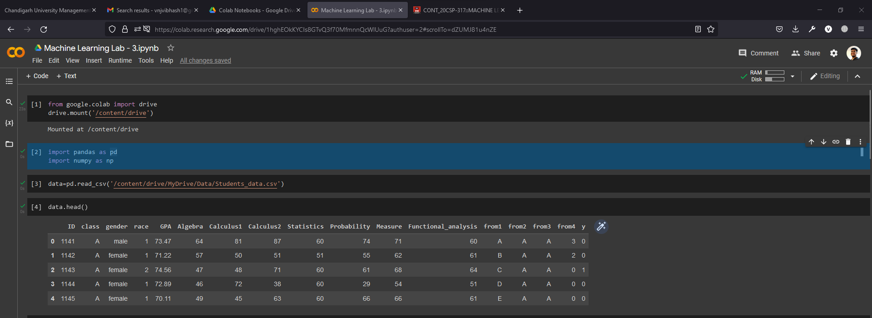

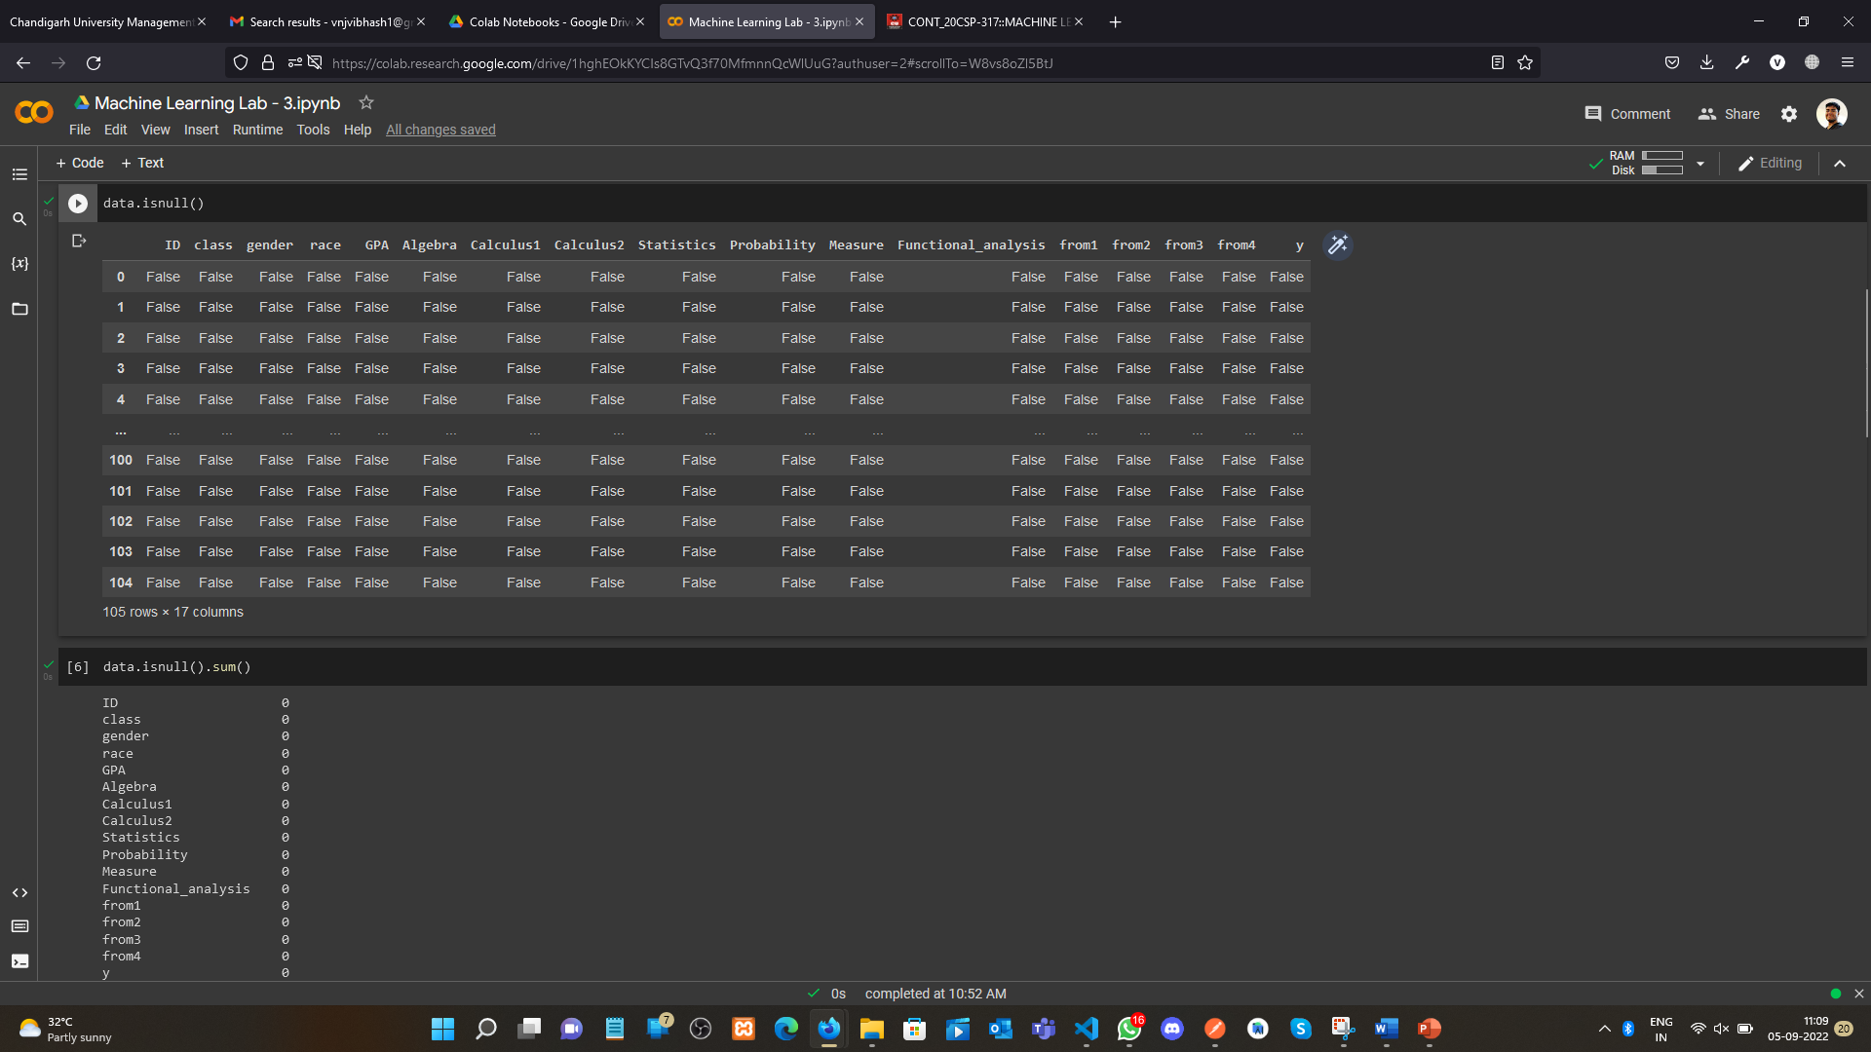

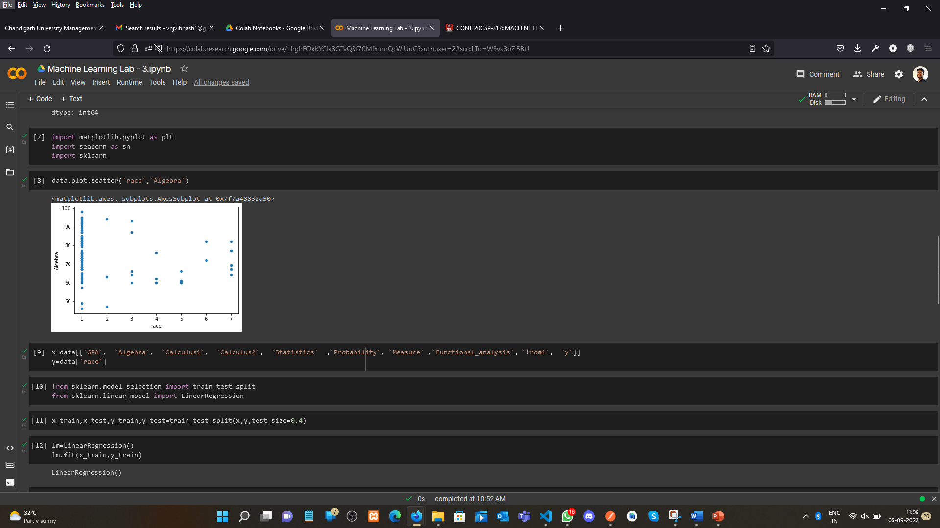

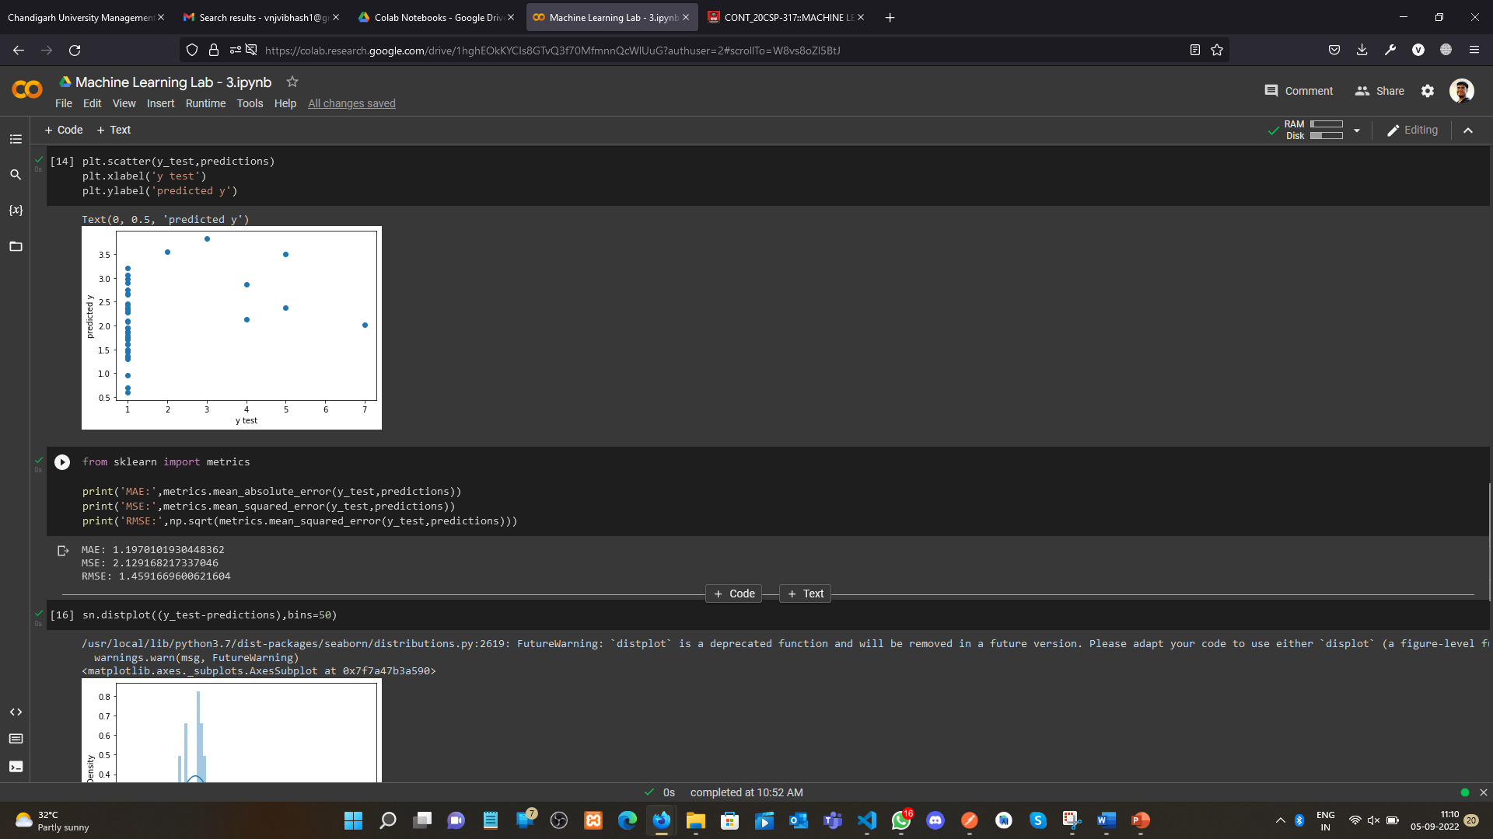

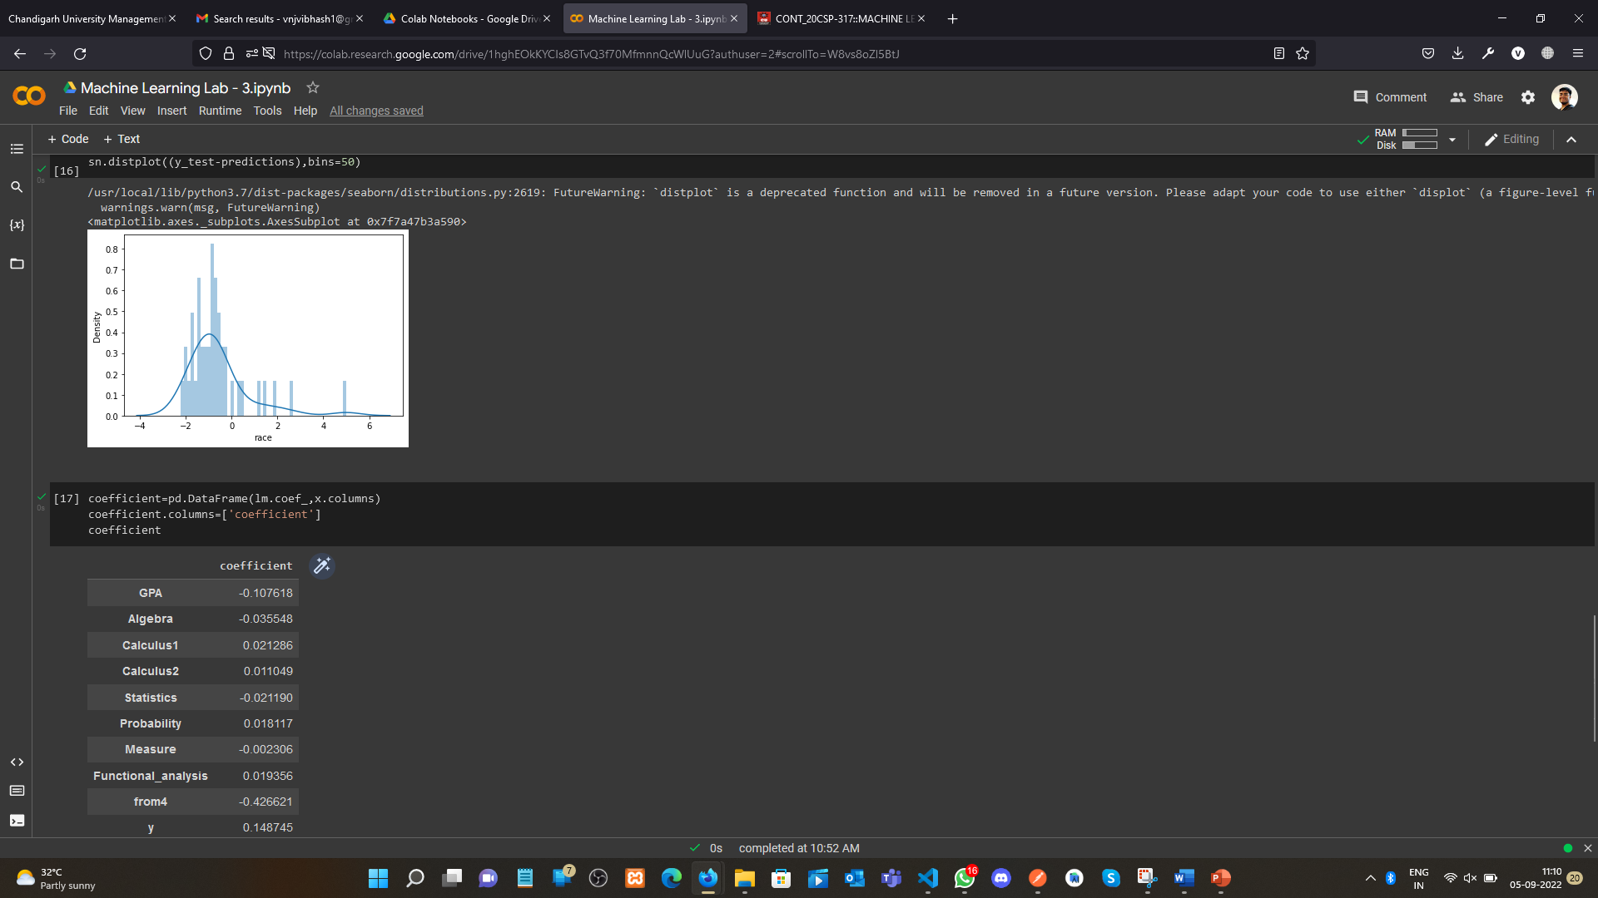

**Learning outcomes (What I have learnt):**

1. Data Splitting
2. Linear regression concept
3. Plotting the prediction.

**Evaluation Grid (To be created as per the SOP and Assessment guidelines by the faculty):**

|  |  |  |  |
| --- | --- | --- | --- |
| Sr. No. | Parameters | Marks Obtained | Maximum Marks |
| 1. |  |  |  |
| 2. |  |  |  |
| 3. |  |  |  |
|  |  |  |  |